Task 4: Build a Production-Ready EKS Cluster With Private Nodes + Public ALB. With diagram.
Key Activities
· Create EKS cluster with private subnets only.
· Create public subnets only for ALB.
· Enable VPC CNI custom networking.
· Deploy:
o ALB Ingress Controller
o NGINX App using Ingress
· Ensure worker nodes have no public IP.
· Test access only through ALB.

subnet  - public Subnet A/B | - ALB only

Private Subnet A/B |  | - EKS worker nodes

Create ->

1. EKS control plane: Private endpoint only
2.Worker nodes:
1.In private subnets
2.No public IP
3.Public subnets:
- Used only by ALB
4.Ingress: AWS ALB Ingress Controller
5.Application: NGINX exposed only via ALB
6. Networking: VPC CNI Custom Networking enabled
7.Access: App reachable only through ALB DNS

Internet
↓
Public ALB (Public Subnets)
↓
Worker nodes (Private Subnets)
↓
Vpc

01-vpc.yaml ->

• 1 VPC
• 2 Public subnets (ALB)
• 2 Private subnets (nodes)
• 1 NAT Gateway

verify
aws ec2 describe-vpcs --filters Name=tag:Name,Values=eksctl-prod-eks-private-cluster/VPC

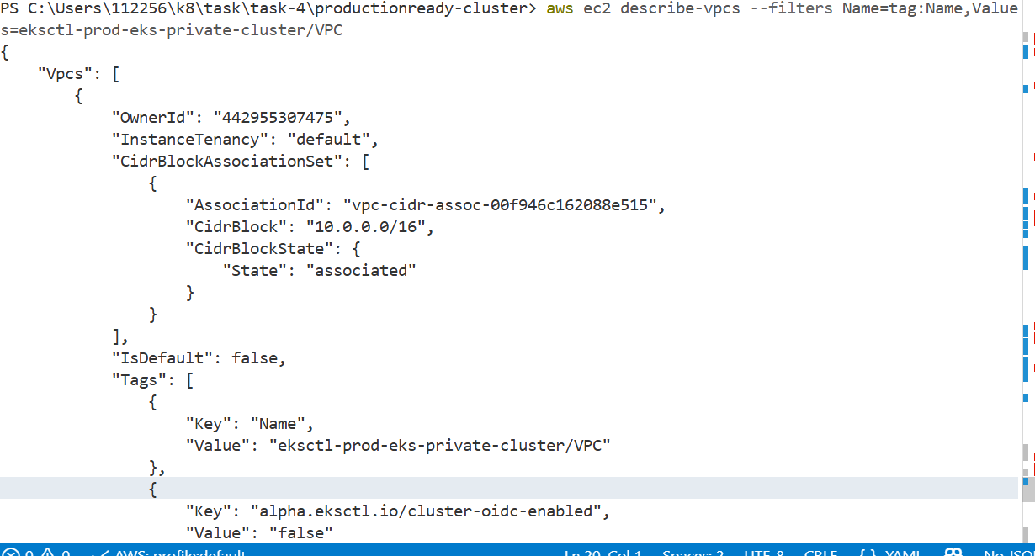

aws ec2 describe-subnets \
--filters Name=vpc-id,Values=<VPC-ID>

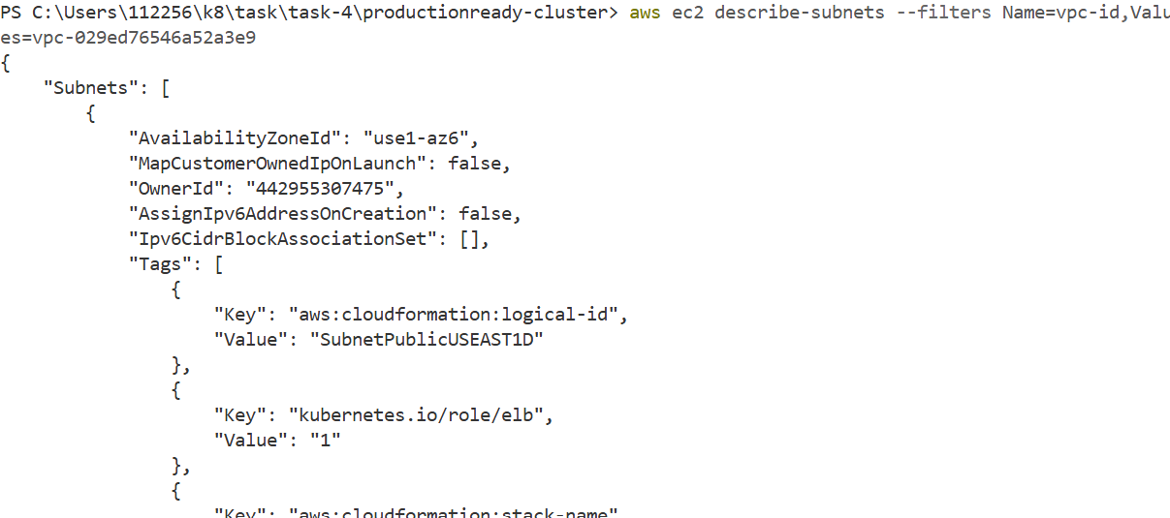

02-eks-cluster.yaml

aws eks describe-cluster --name prod-eks-private --query "cluster.status" --output text

aws eks describe-cluster --name prod-eks-private --query "cluster.resourcesVpcConfig"
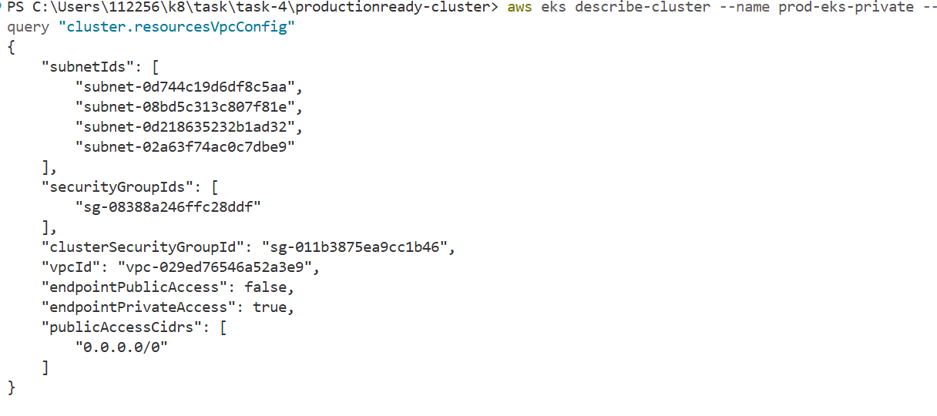

03-nodegroup.yaml

kubectl get nodes

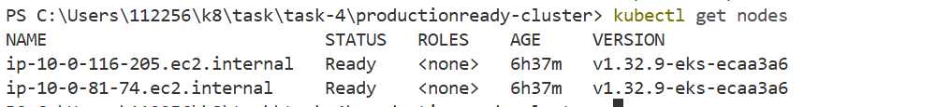

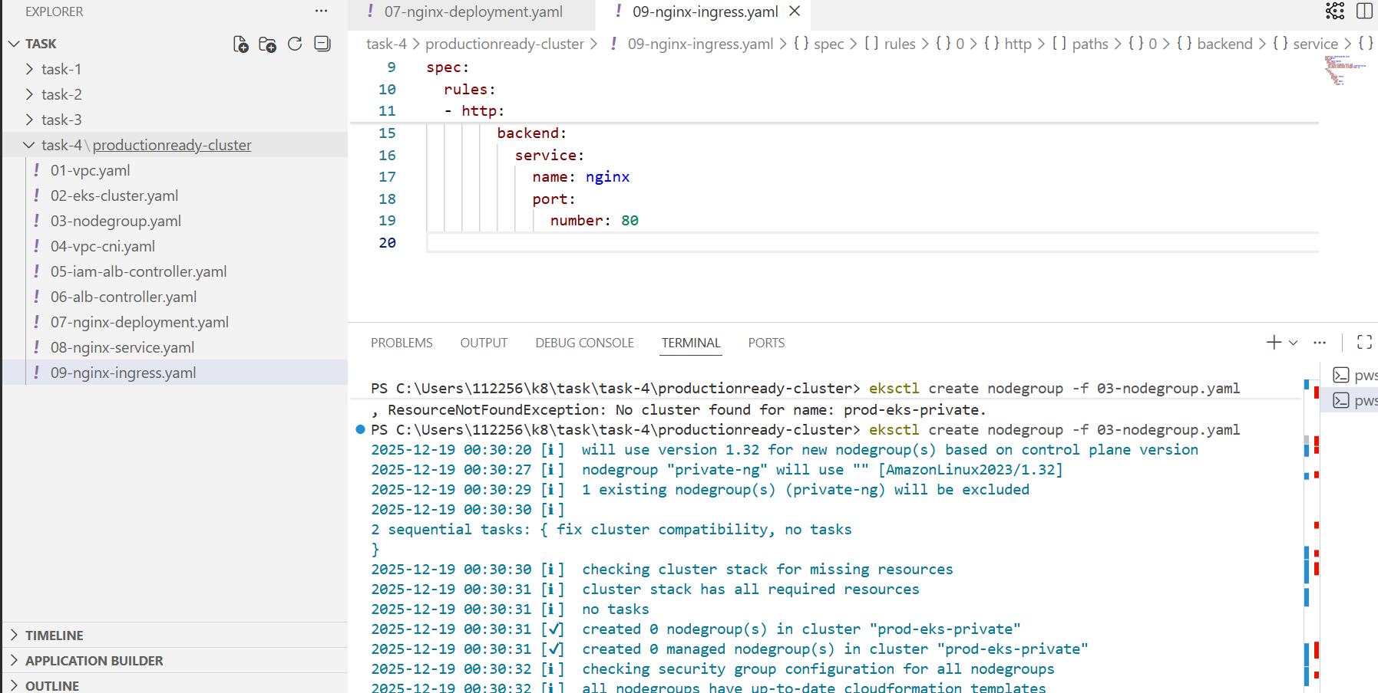

kubectl get nodes -o wide

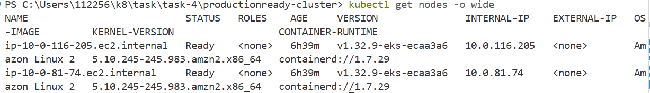

04-vpc-cni.yaml — Verify Custom Networking

kubectl get configmap amazon-vpc-cni -n kube-system -o yaml
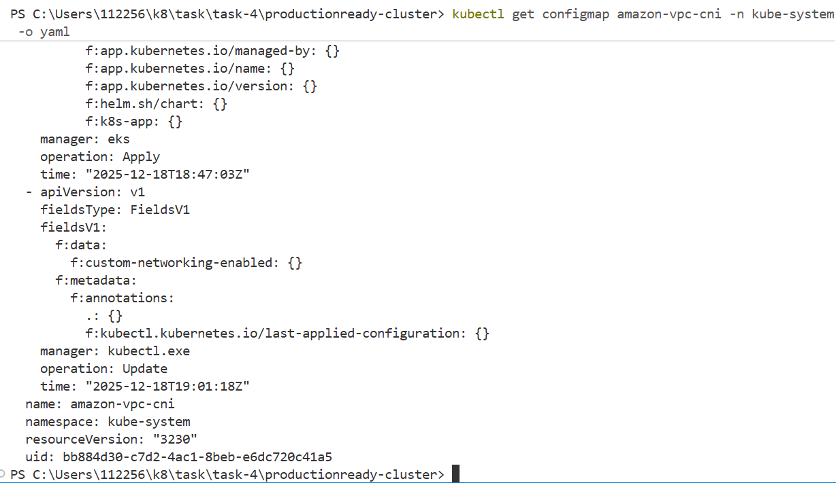

05-iam-alb-controller.yaml — Verify IAM Service Account

Verify ServiceAccount

kubectl get sa aws-load-balancer-controller -n kube-system

Verify IAM role attached
eksctl get iamserviceaccount --cluster prod-eks-private
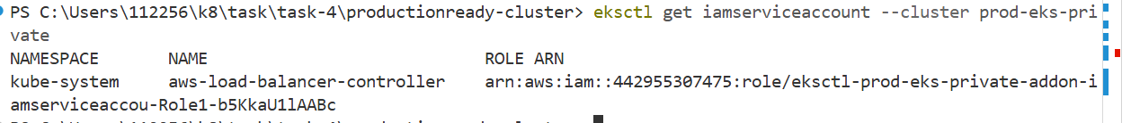

06-alb-controller.yaml — Verify ALB Controller

kubectl get pods -n kube-system | findstr load-balancer

07-nginx-deployment.yaml — Verify App Pods
Verify deployment
kubectl get deployment nginx

Verify pods -
kubectl get pods -l app=nginx

8-nginx-service.yaml
Verify Service

kubectl get svc nginx

09-nginx-ingress.yaml — Verify ALB Creation
kubectl get ingress

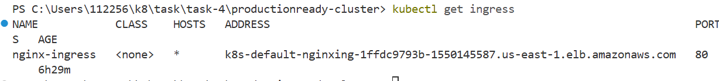

Verify ALB in AWS
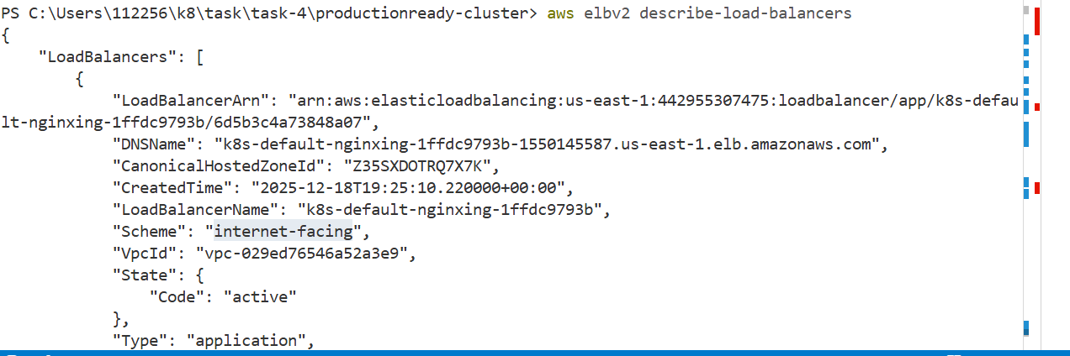

ALB access
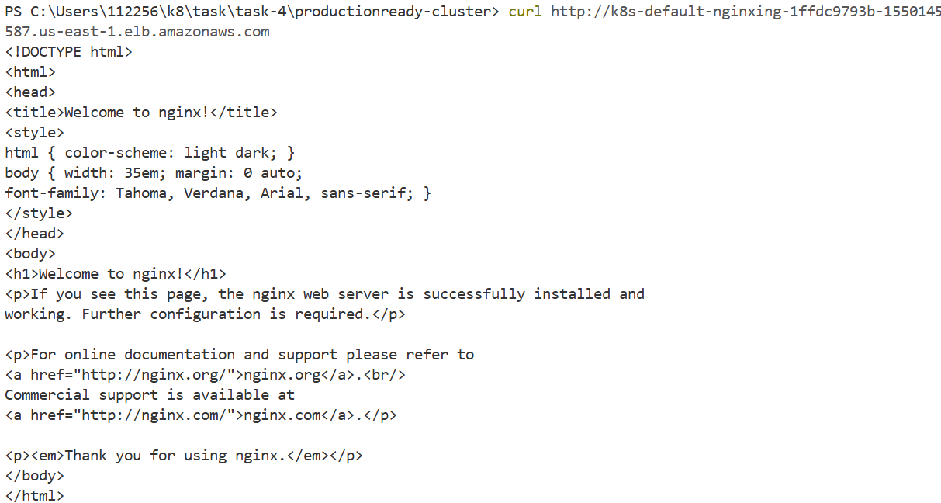

http://k8s-default-nginxing-1ffdc9793b-1550145587.us-east-1.elb.amazonaws.com/

